LAUDA Award For Itzik Avni

Sales Excellence and Market Diversification Key to Success

Lauda-Königshofen, 7 March, 2024 – In February 2024, the Israeli LAUDA agency Meshulam Avni & Son Ltd. was honored with the prestigious LAUDA Award »Important agency with highest sales increase« for its unprecedented sales success. This marks the fourth time the company has received this honor, having previously been recognized in 2000 and 2006 for significant sales increases, and in 2007 for its long-standing partnership.

The current award recognizes the company's exceptional sales development compared to the previous year. It is noteworthy that the company has diversified its business under the leadership of Itzik Avni, son of the company founder. Outstanding growth was achieved in the industrial sector, with a particular increase in demand for testing and measurement technology for high-tech applications.

»Our long-standing, trusting partnership with Meshulam Avni & Son Ltd. has been the foundation of our success since 1970, the year I was born,« acknowledges Dr. Gunther Wobser, President and CEO of LAUDA. »The ability to strengthen existing customer relationships and at the same time open up new markets demonstrates the excellence and commitment of Itzik Avni and his team.«

An important milestone in the past year was the acquisition of Mobileye, a leading global provider of camera systems for autonomous driving, as a new customer. With this step, Meshulam Avni & Son has strengthened its position in the emerging market for autonomous vehicles. In addition to high customer satisfaction through first-class service, Itzik Avni places great importance on continuously developing the sales strategy. As part of the LAUDA strategy project 'Drive250', an experienced pharmaceutical expert, Ms. Gallit Melamed, was recently recruited as an additional sales representative. Despite the unforeseen challenges of recent months, Itzik Avni's team remains determined to continue and intensify its sales activities.

LAUDA congratulates Itzik Avni and Meshulam Avni & Son Ltd. on this well-deserved recognition and looks forward to a continued successful partnership.

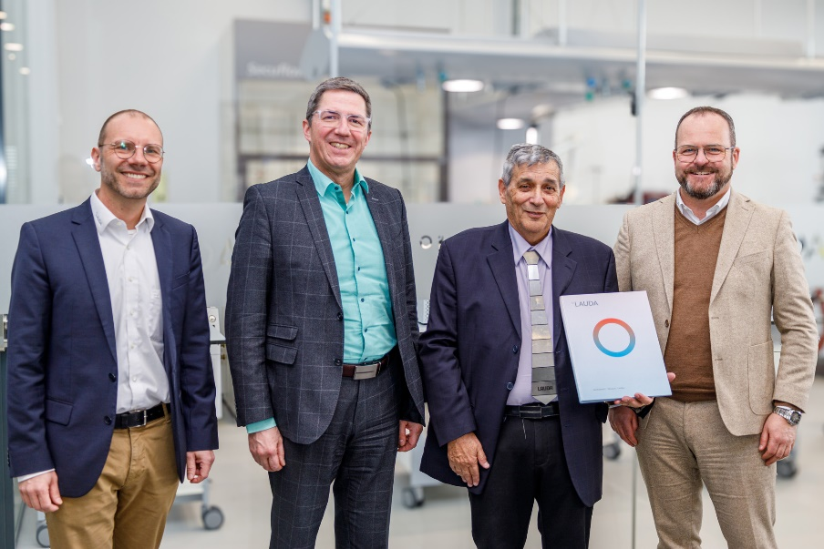
Image: LAUDA Area Sales Manager Marco Hauser, Dr. Ralf Hermann, LAUDA Managing Director, Itzik Avni from Meshulam Avni & Son Ltd. and the President and CEO of LAUDA, Dr. Gunther Wobser (from left to right). © LAUDA

We are LAUDA – the world leader in precise temperature control. Our constant temperature equipment and systems are at the heart of important applications, contributing to a better future. As a complete one-stop supplier, we guarantee the optimum temperature in research, production and quality control. We are the reliable partner for electromobility, hydrogen, chemicals, pharmaceuticals/biotech, semiconductors and medical technology. We have been inspiring our customers for almost 70 years with our expert mentoring and innovative solutions – every day anew and all over the world.

In our company, we always go one step further. We support our employees’ development and are constantly developing ourselves: to create a better future together.

Press contact
We are more than happy to make prepared information about our company, the LAUDA Factory Gallery and our projects in the area of innovation promotion, digitalization and idea management available to the press. We look forward to hearing from you – just give us a call!

CHRISTOPH MUHR
Head of Corporate Communications
T + 49 (0) 9343 503-349
christoph.muhr@lauda.de

LAUDA DR. R. WOBSER GMBH & CO. KG, Laudaplatz 1, 97922 Lauda-Königshofen, Deutschland/Germany. Limited partnership: Headquarters Lauda-Königshofen, Registration court Mannheim HRA 560069. General partner: LAUDA DR. R. WOBSER Verwaltungs-GmbH, Headquarters Lauda-Königshofen, Registration court Mannheim HRB 560226. Managing Directors: Dr. Gunther Wobser (President & CEO), Dr. Mario Englert (CFO), Dr. Ralf Hermann (CSO), Dr. Marc Stricker (COO)

