Lauda promotes sustainable mobility

New Laudaplatz bus stop officially inaugurated

Lauda-Königshofen, April 22, 2024 – In a trailblazing step towards promoting sustainable modes of transport and commuting, LAUDA DR. R. WOBSER GMBH & CO. KG, the world market leader in precise temperature control, has officially inaugurated the new Laudaplatz bus stop, together with local partners.

The ceremony marked a milestone in the company’s efforts to enable climate-conscious commuting by public transport for its employees and to underscore its commitment to protecting the climate. Dr. Gunther Wobser, President & CEO of LAUDA, emphasized the importance of the initiative: “Our mission to integrate sustainability in every aspect of our business activities has reached a new high point. The new bus stop directly on the doorstep of our company is more than just infrastructure. It is a symbol of our commitment to the future and proof that we are actively putting climate protection into practice.”

The bus stop connects LAUDA directly to the local public transport network, run by the Verkehrsgesellschaft Main-Tauber mbH (VGMT), which significantly improves the accessibility of the company headquarters for employees who don’t have their own vehicle. As a result, commuters and visitors from the Main-Tauber district and the neighboring city of Würzburg can conveniently reach the company by public transport in an eco-friendly way. The buses on lines 942, 943 and 945 serve the Laudaplatz bus stop at intervals that are optimally coordinated with the company’s work schedule. For spontaneous trips outside these times, it’s possible to call a taxi. The Laudaplatz bus stop and the connection to the public transport network is yet another building block in LAUDA’s comprehensive sustainability strategy. This commitment is evident in the company’s certification in accordance with the ISO 14001 environmental management system and its ambitious goal to be fully carbon-neutral by 2030, among other things.

“At a time in which overcoming climate change requires us all to act, we are delighted by the construction and launch of the Laudaplatz bus stop,” says Dr. Mario Englert, Managing Director of LAUDA, highlighting its significance. “It is another small but important step towards minimizing our ecological footprint and rethinking mobility in our promising local area. The bus stop is also a plus point for us in terms of attracting skilled workers from the wider surroundings and the neighboring metropolitan region.”

In 2023, LAUDA already took on a pioneering role in the promotion of sustainable modes of transport with the introduction of a carsharing service for employees using electric company and, as well as the JobRad bicycle leasing service, now offers yet another environmentally friendly means of traveling to work. What’s more, the new bus stop is a visible testimony of the successful collaboration between LAUDA, the Lauda-Königshofen city administration and the VGMT. The integrative approach that led to its realization shows what can be achieved through collective effort and the willingness to innovate. Thorsten Haas, Managing Director of the VGMT, Hubert Segeritz, Deputy Mayor of Lauda-Königshofen and Christoph Kraus, Head of Business Development for Lauda-Königshofen, participated in the inauguration ceremony.
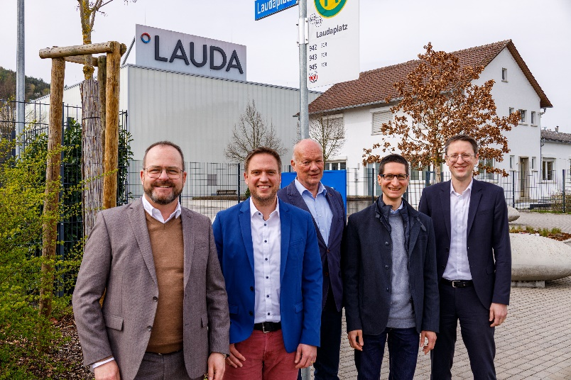

Image: There were satisfied faces all round at the official inauguration of the Laudaplatz bus stop, from left to right: Dr. Gunther Wobser, President & CEO of LAUDA, Thorsten Haas, Managing Director of the Verkehrsgesellschaft Main-Tauber mbH, Hubert Segeritz, Deputy Mayor of Lauda-Königshofen, Christoph Kraus, Head of Business Development for Lauda-Königshofen, and Dr. Mario Englert, Managing Director of LAUDA. © LAUDA

We are LAUDA – the world leader in precise temperature control. Our constant temperature equipment and systems are at the heart of important applications, contributing to a better future. As a complete one-stop supplier, we guarantee the optimum temperature in research, production and quality control. We are the reliable partner for electromobility, hydrogen, chemicals, pharmaceuticals/biotech, semiconductors and medical technology. We have been inspiring our customers for almost 70 years with our expert mentoring and innovative solutions – every day anew and all over the world.

In our company, we always go one step further. We support our employees’ development and are constantly developing ourselves: to create a better future together.

Press contact
We are more than happy to make prepared information about our company, the LAUDA Factory Gallery and our projects in the area of innovation promotion, digitalization and idea management available to the press. We look forward to hearing from you – just give us a call!

CHRISTOPH MUHR
Head of Corporate Communications
T + 49 (0) 9343 503-349
christoph.muhr@lauda.de

LAUDA DR. R. WOBSER GMBH & CO. KG, Laudaplatz 1, 97922 Lauda-Königshofen, Deutschland/Germany. Limited partnership: Headquarters Lauda-Königshofen, Registration court Mannheim HRA 560069. General partner: LAUDA DR. R. WOBSER Verwaltungs-GmbH, Headquarters Lauda-Königshofen, Registration court Mannheim HRB 560226. Managing Directors: Dr. Gunther Wobser (President & CEO), Dr. Mario Englert (CFO), Dr. Ralf Hermann (CSO), Dr. Marc Stricker (COO)

