analytica 2024: LAUDA achieves positive result

The world market leader achieves contacts on par with pre-pandemic levels, thanks to innovative highlights

Lauda-Königshofen, April 23, 2024 – This year’s analytica 2024 broke all records – both in terms of visitor numbers and international participation, as well as the atmosphere on the trade fair grounds in Munich. The four-day trade fair was a big success for LAUDA DR. R. WOBSER GMBH & CO. KG, the world market leader in precise temperature control.

From April 9 to 12, analytica 2024 – the world’s leading trade fair for laboratory technology, analytics and biotechnology – exceeded all the previous year's figures with an impressive 1,066 exhibitors from 42 countries and around 34,000 visitors from 117 countries. These figures were also reflected in LAUDA's positive trade fair result. The company’s impressive stand attracted numerous visitors and its customer contacts were 20 percent higher than the last analytica in 2022. The number of registered contacts was even 10 percent higher than the last pre-pandemic trade fair in 2018.

“We are proud and satisfied with the encouraging response that our new products, Universa and Mobifreeze, and digital services, such as our Command app, have received at analytica 2024,” summarizes Dr. Gunther Wobser, President & CEO of LAUDA. “With numerous visitors and plenty of concrete inquiries, the highly anticipated analytica has delivered a vital impetus for us and the whole industry during economically challenging times.”

New bath thermostats, portable ultra-low-temperature chest freezers and digital products from LAUDA
The specialist audience was impressed by LAUDA’s innovations for the digital and sustainable laboratory of the future. Alongside the world’s first battery-powered Mobifreeze ultra-low-temperature chest freezer, which revolutionizes the transport of active medical substances – such as temperature-sensitive vaccines – the family company also presented new bath thermostats from the LAUDA Universa series of networked devices, which represent flexibility and efficiency in laboratory settings. They feature a modular construction and are highly sustainable, thanks to the use of natural refrigerants. Visitors also showed a great deal of interest in the highlight podiums for the Integral and Variocool bestsellers, where they could control the devices using the Professional version of the LAUDA Command app and discover the benefits of remote maintenance and monitoring first-hand.

For trade media representatives, a separate press conference was held at the LAUDA stand, during which the company management and product marketing introduced the company’s new solutions and highlights and answered any questions.
LAUDA is already eagerly anticipating ACHEMA, which will take place in Frankfurt am Main from June 10 to 14, 2024, and where LAUDA will one again present itself at the world’s biggest trade fair in the process manufacturing industry for chemical technology, process engineering and biotechnology.
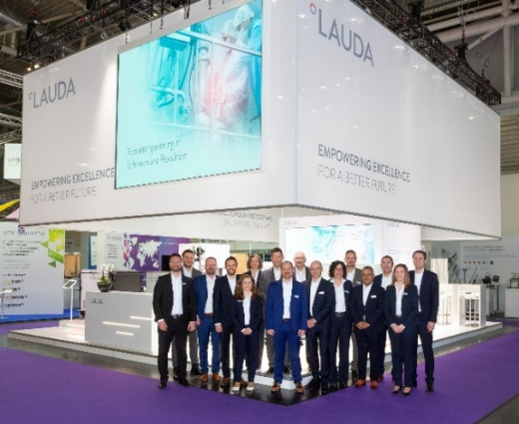 | 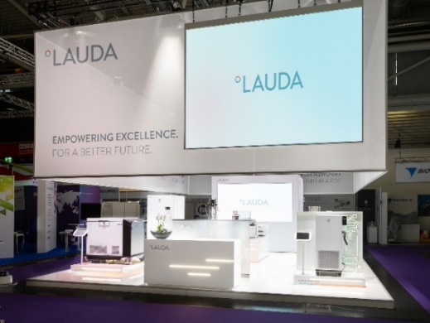
Fig. 1: The LAUDA trade fair stall with the analytica 2024 team © Foto Besserer | Fig. 2: The LAUDA trade fair stand at analytica 2024 © Foto Besserer
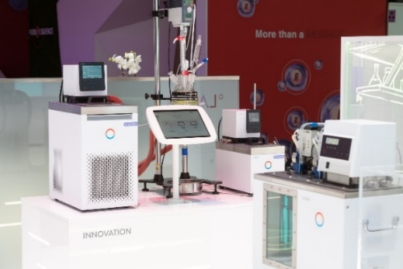 | 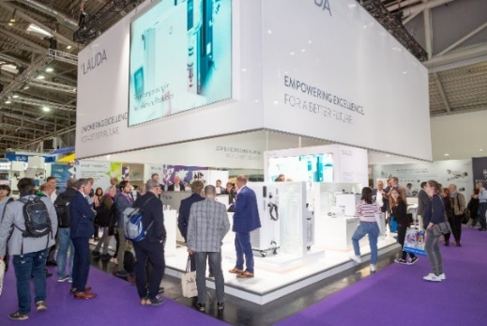
Fig. 3: LAUDA Universa bath thermostats at analytica 2024 © Foto Besserer | Fig. 4: The LAUDA trade fair stall with visitors at analytica 2024 © Foto Besserer

We are LAUDA – the world leader in precise temperature control. Our constant temperature equipment and systems are at the heart of important applications, contributing to a better future. As a complete one-stop supplier, we guarantee the optimum temperature in research, production and quality control. We are the reliable partner for electromobility, hydrogen, chemicals, pharmaceuticals/biotech, semiconductors and medical technology. We have been inspiring our customers for almost 70 years with our expert mentoring and innovative solutions – every day anew and all over the world.

In our company, we always go one step further. We support our employees’ development and are constantly developing ourselves: to create a better future together.

Press contact
We are more than happy to make prepared information about our company, the LAUDA Factory Gallery and our projects in the area of innovation promotion, digitalization and idea management available to the press. We look forward to hearing from you – just give us a call!

CHRISTOPH MUHR
Head of Corporate Communications
T + 49 (0) 9343 503-349
christoph.muhr@lauda.de

LAUDA DR. R. WOBSER GMBH & CO. KG, Laudaplatz 1, 97922 Lauda-Königshofen, Deutschland/Germany. Limited partnership: Headquarters Lauda-Königshofen, Registration court Mannheim HRA 560069. General partner: LAUDA DR. R. WOBSER Verwaltungs-GmbH, Headquarters Lauda-Königshofen, Registration court Mannheim HRB 560226. Managing Directors: Dr. Gunther Wobser (President & CEO), Dr. Mario Englert (CFO), Dr. Ralf Hermann (CSO), Dr. Marc Stricker (COO)

