Roy Lu new General Manager of LAUDA China

Strengthening the Chinese sales subsidiary and focus on growth strategy

Lauda-Königshofen, May 24, 2024 – Roy Lu is the new general manager of the sales subsidiary LAUDA China, which manages the global product range of LAUDA DR. R. WOBSER GMBH & CO. KG, the leading manufacturer of temperature control devices and systems. The 41-year-old electrical engineer has many years of experience in technical sales and has, among other things, worked for German branches in China such as Siemens and medium-sized companies such as Lenze. Most recently, he was responsible for the Chinese branch of a German manufacturer of connection systems and successfully expanded the business there.

Dr. Gunther Wobser, President & CEO of LAUDA, was together with the Director Area Sales International, Dr. Thorsten Ebel, on site in Shanghai to welcome the new employee. Convinced of the market opportunities in China, Dr. Wobser on the successful filling of the position: “The dynamics in China are unbroken in the medium and long term. In addition to our core markets in chemistry and biotechnology, we want to exploit opportunities in electromobility and hydrogen technology. Globally leading companies in particular rely on globally valid quality standards, which we, as the recognized world market leader for precise temperature control, offer with our own presence in all important markets.”

By filling this key position, LAUDA China is ideally prepared for the future and will concentrate on implementing the Drive250 growth strategy with Roy Lu. Dr. Ebel, who has been intensively supporting the team himself for several months, adds: “With Roy Lu, we have been able to gain an experienced manager who will further develop the market with the competent team. We will continue to expand our sales in the short term.”

LAUDA China was founded in 2008 and supports local dealers and end customers. Since the beginning of 2024, the Shanghai-based company has acted as a logistics hub and sells the entire LAUDA device portfolio in the strategically important region. The business has expanded significantly in recent years in particular.
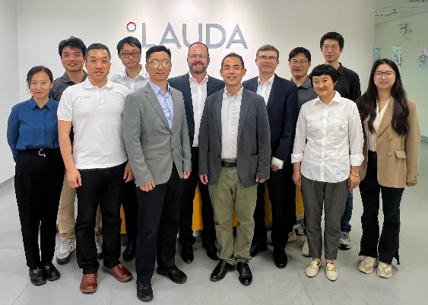 | 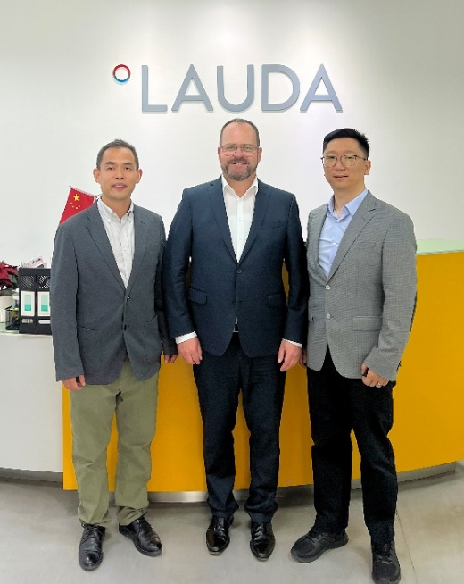
Fig. 1: The new General Manager of LAUDA China, Roy Lu (fifth from left) is greeted by Dr. Gunther Wobser, President & CEO of LAUDA DR. R. WOBSER GMBH & CO. KG (sixth from left), together with Dr. Thorsten Ebel, Director Area Sales International (fifth from the right) and the team welcomed. © LAUDA | Fig. 2: Roy Lu, the new General Manager of the sales subsidiary LAUDA China (right), is greeted by Dr. Gunther Wobser, President & CEO (center), is welcomed together with the Managing Director of the Chinese plant LAUDA Production China, Ernest Liu (left). © LAUDA

We are LAUDA – the world leader in precise temperature control. Our constant temperature equipment and systems are at the heart of important applications, contributing to a better future. As a complete one-stop supplier, we guarantee the optimum temperature in research, production and quality control. We are the reliable partner for electromobility, hydrogen, chemicals, pharmaceuticals/biotech, semiconductors and medical technology. We have been inspiring our customers for almost 70 years with our expert mentoring and innovative solutions – every day anew and all over the world.

In our company, we always go one step further. We support our employees’ development and are constantly developing ourselves: to create a better future together.

Press contact
We are more than happy to make prepared information about our company, the LAUDA Factory Gallery and our projects in the area of innovation promotion, digitalization and idea management available to the press. We look forward to hearing from you – just give us a call!

CHRISTOPH MUHR
Head of Corporate Communications
T + 49 (0) 9343 503-349
christoph.muhr@lauda.de

LAUDA DR. R. WOBSER GMBH & CO. KG, Laudaplatz 1, 97922 Lauda-Königshofen, Deutschland/Germany. Limited partnership: Headquarters Lauda-Königshofen, Registration court Mannheim HRA 560069. General partner: LAUDA DR. R. WOBSER Verwaltungs-GmbH, Headquarters Lauda-Königshofen, Registration court Mannheim HRB 560226. Managing Directors: Dr. Gunther Wobser (President & CEO), Dr. Mario Englert (CFO), Dr. Ralf Hermann (CSO), Dr. Marc Stricker (COO)

