SUCCESSFUL CHINA PREMIERE OF THE SUMMIT FOR WORLD MARKET LEADERS

Dr. Gunther Wobser represents LAUDA at the strategically important event

Lauda-Königshofen, May 27, 2024 – A summit for world market leaders with around 400 participants took place in Beijing for the first time. The initiators were the Academy of World Market Leaders, which was founded by the former Economics Minister of Baden-Württemberg, Dr. Walter Döring, and the German-European Center for SME Cooperation DEZ in China. The venue was the impressive “Beijing-China-Germany International Convention and Exhibition Center” building complex in the middle of the Shunyi district, in the immediate vicinity of the Chinese capital’s airport. There is a large industrial area in which predominantly German companies such as Mercedes-Benz, Bosch and the medium-sized company Wilo have settled.

China is very impressed by the success strategies of the so-called hidden champions, leading global companies, of which there are around 1,700 in Germany. Above all, the big names are known abroad. A similar phenomenon exists in China, whose economic structure largely consists of small and medium-sized privately owned companies, although most of them do not yet have global sales structures.

The German world market leaders included ebm-papst, represented by the managing director responsible for sales, Thomas Nürnberger, Würth, represented by the foundation's former chairman of the board, Harald Unkelbach, and LAUDA, represented by President & CEO, Dr. Gunther Wobser, attended the summit.

The delegation of around 100 German company representatives was accompanied, among others, by the former German Economics Minister, Peter Altmaier, as well as the long-time member of the Bundestag, former minister and current chairman of the German-Chinese parliamentary group and the China Bridge dialogue platform, Dr. Hans Peter Friedrich.

Dr. Gunther Wobser took part in a panel discussion about the opportunities for German-Chinese cooperation and presented the family business LAUDA in the large plenary session. He focused on the important collaboration in the growth industries of electromobility and hydrogen drives, for example for trucks, and LAUDA's powerful product range as the world market leader for precise temperatures. He referred to the Chinese sales company, which has existed since 2008 and the production set up in 2023, which develops and produces first-class LAUDA devices from China worldwide.

The highlight was the reception of a small delegation by the Vice Minister for Trade and International Economic Relations, Ling Ji. Minister Ling Ji explicitly asked the company representatives about opportunities for improvement and took intensive notes. The protection of intellectual property, which is particularly important for German companies, was mentioned several times. Dr. Gunther Wobser asked for support with the required CCC certification and cited difficulties for his two Chinese subsidiaries in accessing digital information from the German headquarters. Minister Ling Ji then commented in detail on the individual points and generally pledged his support.

The Chinese government is showing increasing interest in creating investment-promoting conditions for German medium-sized businesses and thus attracting investments into the country. German world market leaders, in turn, want to continue to play an active role in Chinese economic life and expand their market position in the important sales market. As the conference showed, they are open to targeted cooperation with Chinese customers and family businesses.

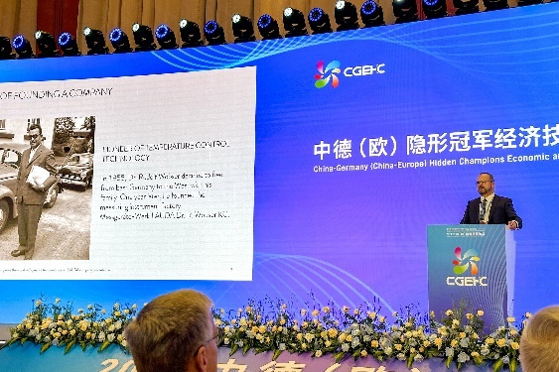 | 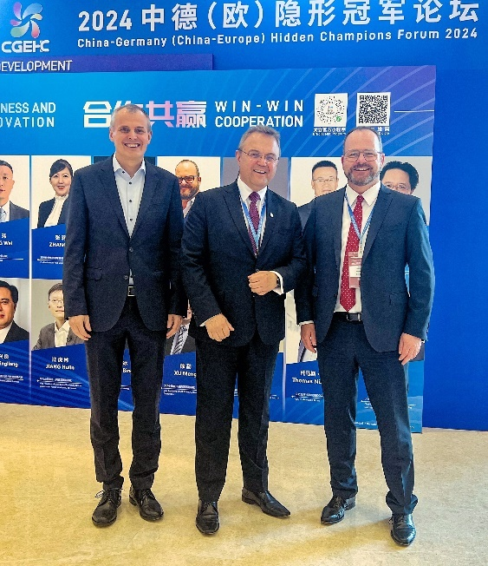
Fig. 1: Presentation of LAUDA by Dr. Gunther Wobser at the summit for world market leaders in Beijing. © LAUDA | Fig. 2 (from right to left): Dr. Gunther Wobser, Managing Partner of LAUDA, Dr. Hans-Peter Friedrich (chairman of the German-Chinese parliamentary group) and Thomas Nürnberger, managing director of ebm-papst, were satisfied with the discussions. © LAUDA
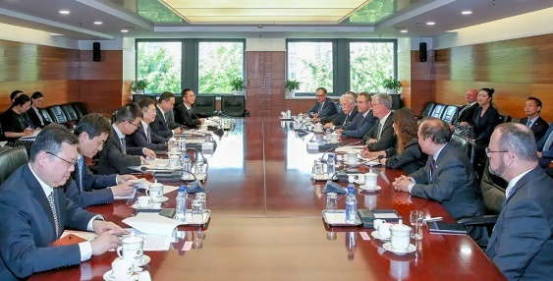 | 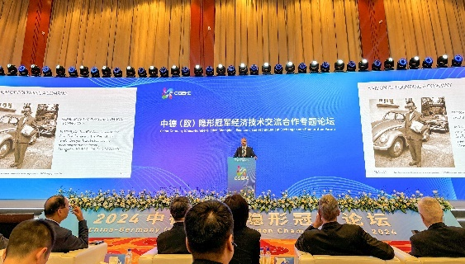
Fig. 3: Dr. Gunther Wobser (front right) receiving a delegation with open exchanges with Ling Ji, Vice Minister for Trade and International Economic Relations. © LAUDA | Fig. 4: Big stage for the so-called hidden champions: Dr. Wobser at his presentation of LAUDA DR. R. WOBSER GMBH & CO. KG. © LAUDA

We are LAUDA – the world leader in precise temperature control. Our constant temperature equipment and systems are at the heart of important applications, contributing to a better future. As a complete one-stop supplier, we guarantee the optimum temperature in research, production and quality control. We are the reliable partner for electromobility, hydrogen, chemicals, pharmaceuticals/biotech, semiconductors and medical technology. We have been inspiring our customers for almost 70 years with our expert mentoring and innovative solutions – every day anew and all over the world.

In our company, we always go one step further. We support our employees’ development and are constantly developing ourselves: to create a better future together.

Press contact
We are more than happy to make prepared information about our company, the LAUDA Factory Gallery and our projects in the area of innovation promotion, digitalization and idea management available to the press. We look forward to hearing from you – just give us a call!

CHRISTOPH MUHR
Head of Corporate Communications
T + 49 (0) 9343 503-349
christoph.muhr@lauda.de

LAUDA DR. R. WOBSER GMBH & CO. KG, Laudaplatz 1, 97922 Lauda-Königshofen, Deutschland/Germany. Limited partnership: Headquarters Lauda-Königshofen, Registration court Mannheim HRA 560069. General partner: LAUDA DR. R. WOBSER Verwaltungs-GmbH, Headquarters Lauda-Königshofen, Registration court Mannheim HRB 560226. Managing Directors: Dr. Gunther Wobser (President & CEO), Dr. Mario Englert (CFO), Dr. Ralf Hermann (CSO), Dr. Marc Stricker (COO)

