LAUDA PRESENTS NUMEROUS REFRIGERATION INNOVATIONS
ACHEMA 2024

Lauda-Königshofen, May 29, 2024 - LAUDA, the world's leading supplier of precise temperature solutions, will present a wide range of innovations at this year's ACHEMA in Frankfurt am Main. Two new product lines and a focus on sustainability, energy efficiency, and natural refrigerants will characterize the LAUDA presentation this year. In addition, a cross-section of the extensive portfolio of process thermostats, circulation chillers, and plant engineering will be on display.

Ultratemp Process Thermostats - High-performance Temperature Control for Biotechnology and Pharmaceutical Technology
LAUDA Ultratemp represents a new generation of process thermostats - powerful and precise, designed for demanding applications in the biotechnology and pharmaceutical industries. With impressive heating and cooling capacities of up to 50 kW, a temperature stability of ±0.5 K, and an operating range of -5 °C - 60 °C, Ultratemp process thermostats meet the highest demands. Their robust, easy-to-clean stainless-steel construction and intuitive operation via buttons and LCD allow efficient and precise use. Their bi-frequency power supply and the wide ambient temperature range of -15 °C - 50 °C make them fit for global use. Conceived for biopharmaceutical applications, they can effectively control large volumes of up to 5,000 liters. LAUDA Ultratemp process thermostats will be presented to the public for the first time at ACHEMA.

Universa bath thermostats - modular, sustainable, digital, and powerful
The new LAUDA Universa range of devices comprises three primary performance classes: Universa ECO, Universa PRO, and Universa MAX, which cover all laboratory and pilot plant requirements, from cost-effective entry-level units to powerful professional thermostats. LAUDA Universa has a completely modular design. The control heads and baths can be flexibly combined. With bath volumes of 4 - 42 L and bath depths of 160 - 320 mm as well as cooling capacities of up to 1.5 kW and heating capacities of up to 3.6 kW, the ideal technical solution can be configured for every application and an optimum price/performance ratio ensured. All units in the range use natural refrigerants and frequency-controlled compressors. The latter allows energy-saving operation, especially at partial load. Examples of the Universa U 8 PRO, Universa U 1645 MAX, and Universa U 845 MAX will be on display at the trade fair.

Focus on natural refrigerants and efficiency
In addition to the new product lines, numerous innovative refrigeration solutions for the process industry will be presented, which cover different performance classes and requirements and can be flexibly integrated into complex process structures. A selection from the extensive portfolio of process thermostats and circulation chillers will be on display - with a focus on energy efficiency, sustainability, and natural refrigerants. From propane- and CO2-based process thermostats with a single-digit GWP (Global Warming Potential) value to the current generation of circulation chillers, which enable energy savings of up to 50 percent compared to older, still widely used models, LAUDA underlines its commitment to sustainable development. "Empowering Excellence. For a better future" is both a vision and a commitment, manifested in a comprehensive sustainability strategy that combines technical feasibility, visionary thinking, and a sense of purpose.

Image 1: LAUDA_Ultratemp.jpg
The new Ultratemp process thermostat is ideal for the pharmaceutical and biotechnology environment. © lauda.de

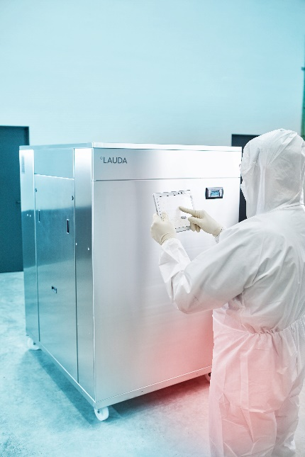

Picture 2: LAUDA_Universa.jpg
LAUDA Universa combines the entire portfolio of LAUDA bath and circulation thermostats in one device line - modular, sustainable, digital, and powerful. © lauda.de

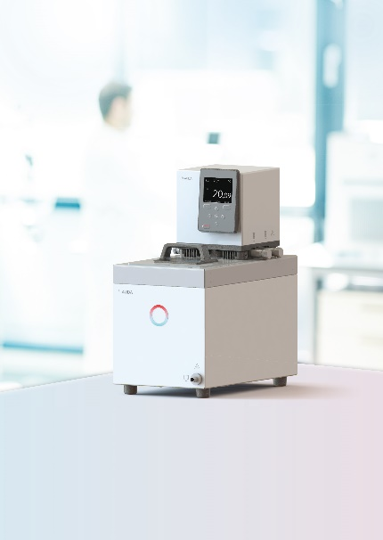

We are LAUDA – the world leader in precise temperature control. Our constant temperature equipment and systems are at the heart of important applications, contributing to a better future. As a complete one-stop supplier, we guarantee the optimum temperature in research, production and quality control. We are the reliable partner for electromobility, hydrogen, chemicals, pharmaceuticals/biotech, semiconductors, and medical technology. We have been inspiring our customers for almost 70 years with our expert mentoring and innovative solutions – every day anew and all over the world.

In our company, we always go one step further. We support our employees’ development and are constantly developing ourselves: to create a better future together.

Press contact
We would be happy to provide you with further information and images of our (digital) products or discuss possible trade articles and cross-media presentations of our solutions with you.

Contact us – we look forward to talking to you!

AYLA WOLF CHRISTOPH MUHR
Product Marketing Head of Corporate Communications
T + 49 (0) 9343 503-398 T + 49 (0) 9343 503-349
ayla.wolf@lauda.de christoph.muhr@lauda.de

LAUDA DR. R. WOBSER GMBH & CO. KG, Laudaplatz 1, 97922 Lauda-Königshofen, Deutschland/Germany. Limited partnership: Headquarters Lauda-Königshofen, Registration court Mannheim HRA 560069. General partner: LAUDA DR. R. WOBSER Verwaltungs-GmbH, Headquarters Lauda-Königshofen, Registration court Mannheim HRB 560226. Managing Directors: Dr. Gunther Wobser (President & CEO), Dr. Mario Englert (CFO), Dr. Ralf Hermann (CSO), Dr. Marc Stricker (COO)

