ACHEMA 2024: LAUDA looks back on a successful exhibition

World market leader presents groundbreaking new products in Frankfurt am Main

Lauda-Königshofen, June 17, 2024 – LAUDA DR. R. WOBSER, the world's leading provider of precise temperature solutions, draws an extremely positive conclusion from ACHEMA 2024, the world's leading trade fair for the process industry. From June 10 to 14, the exhibition center in Frankfurt am Main was once again the meeting place for the chemical and pharmaceutical technology, biotechnology and industrial environmental technology sectors. Over the five days of the trade fair, 106,000 visitors from 141 nations found out about the products and services of the 2,842 exhibitors from 56 countries.

With a modern, bright and inviting exhibition stand, LAUDA presented itself to the international trade audience from its best side. The presentation of two new product lines, the LAUDA Ultratemp process thermostats and the Universa bath thermostats, as well as a strong focus on sustainability, energy efficiency and digital products such as the LAUDA Command App characterized the world market leader's trade fair appearance. In numerous discussions with process engineers, biotechnologists, engineers, chemists and other industry experts, LAUDA's groundbreaking refrigeration innovations were convincing across the board.

Product innovations: Ultratemp process thermostats and Universa bath thermostats
At ACHEMA 2024, LAUDA presented the Ultratemp process thermostats to the public for the first time: These impress with their performance and precision and meet the highest requirements for demanding applications in the biotechnology and pharmaceutical industries.

As an innovative solution that is characterized by its modular design and the flexible combinability of control heads and baths, LAUDA presented the new Universa product line. The devices work with natural refrigerants and frequency-controlled compressors, which enable energy-saving operation, especially in partial load operation. With the Universa U 8 PRO, the Universa U 1645 MAX and the Universa U 845 MAX, LAUDA is presenting tailor-made and high-performance solutions for a wide range of applications in the laboratory sector at the trade fair.

Dr. Gunther Wobser, President & CEO of LAUDA, was satisfied with the course of the trade fair: “We are proud of how our innovations were received at ACHEMA 2024. The positive response and the continued high level of interest confirm our position as global market leader. Compared to the last ACHEMA, which was significantly weaker in 2022 due to the pandemic, we were able to increase the number of registered contacts by 154 percent. We see this as a positive signal for the challenging financial year.”
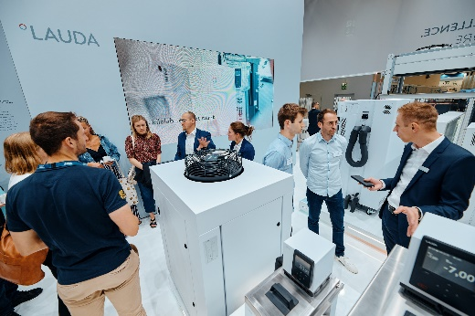 | 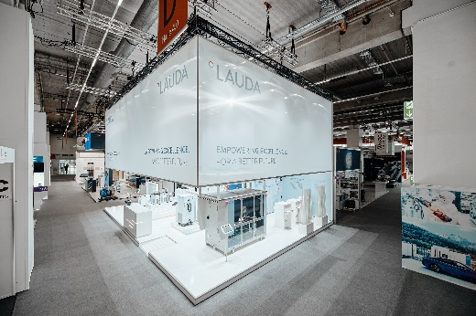
Fig. 1: LAUDA exhibition stand with visitors ACHEMA 2024 © Chris Rausch | Fig. 2: LAUDA exhibition stand ACHEMA 2024. © Chris Rausch
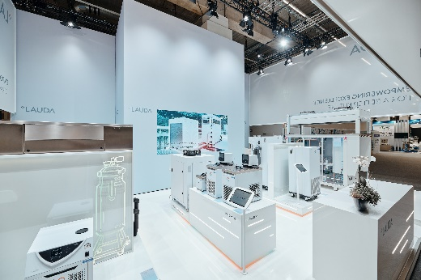 | 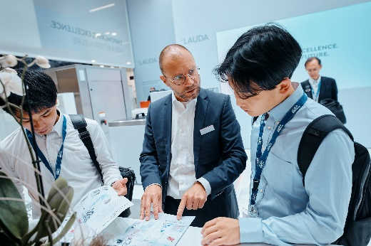
Fig. 3: LAUDA exhibition stand with exhibits ACHEMA 2024 © Chris Rausch | Fig. 4: LAUDA exhibition stand consultation ACHEMA 2024 © Chris Rausch
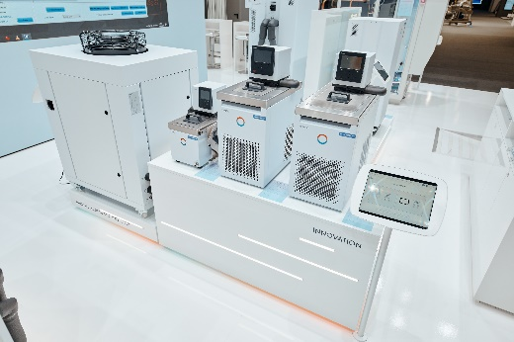 | 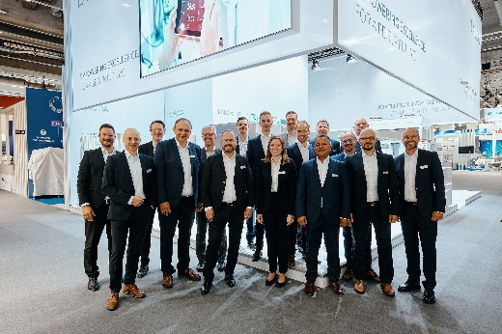
Fig. 5: Bath thermostats LAUDA Universa ACHEMA 2024 © Chris Rausch | Fig. 6: LAUDA exhibition stand with team ACHEMA 2024. © Chris Rausch

We are LAUDA – the world leader in precise temperature control. Our constant temperature equipment and systems are at the heart of important applications, contributing to a better future. As a complete one-stop supplier, we guarantee the optimum temperature in research, production and quality control. We are the reliable partner for electromobility, hydrogen, chemicals, pharmaceuticals/biotech, semiconductors and medical technology. We have been inspiring our customers for almost 70 years with our expert mentoring and innovative solutions – every day anew and all over the world.

In our company, we always go one step further. We support our employees’ development and are constantly developing ourselves: to create a better future together.

Press contact
We are more than happy to make prepared information about our company, the LAUDA Factory Gallery and our projects in the area of innovation promotion, digitalization and idea management available to the press. We look forward to hearing from you – just give us a call!

CHRISTOPH MUHR
Head of Corporate Communications
T + 49 (0) 9343 503-349
christoph.muhr@lauda.de

LAUDA DR. R. WOBSER GMBH & CO. KG, Laudaplatz 1, 97922 Lauda-Königshofen, Deutschland/Germany. Limited partnership: Headquarters Lauda-Königshofen, Registration court Mannheim HRA 560069. General partner: LAUDA DR. R. WOBSER Verwaltungs-GmbH, Headquarters Lauda-Königshofen, Registration court Mannheim HRB 560226. Managing Directors: Dr. Gunther Wobser (President & CEO), Dr. Mario Englert (CFO), Dr. Ralf Hermann (CSO), Dr. Marc Stricker (COO)

