LAUDA TECHNOLOGY SETS STANDARDS IN PLANT ENGINEERING

Achievements honored for the fifth time with the LAUDA Award

Lauda-Königshofen, June 24, 2024 – LAUDA Technology Ltd, the British sales company of LAUDA DR. R. WOBSER GMBH & CO. KG, has once again been honored for its outstanding performance with the “Best Agency for Plant Engineering” award. The award ceremony took place on June 11 at the LAUDA stand during the ACHEMA trade fair in Frankfurt am Main. This is the fifth time that LAUDA Technology Ltd. has received this award; the company was last honored in 2022. Special mention was made of the achievements of Paul King and John Telford, Sales Manager Industrial Units, who once again demonstrated their outstanding performance.

In the presence of Dr. Ralf Hermann, CSO of LAUDA and responsible for sales, service and product management, and Dr. Thorsten Ebel, Director Area Sales International at LAUDA, the President & CEO of LAUDA, Dr. Gunther Wobser, presented the award and expressed his appreciation: “It is a remarkable achievement to be so successful in these challenging times. LAUDA Technology, with John Telford as a specialist in plant engineering, has once again demonstrated a high level of technical competence”.

Dr. Hermann praised the performance of the British subsidiary: “The sales growth of LAUDA Technology is impressive every year. It surpasses itself again and again. We are very pleased with this positive development and would like to thank the entire LAUDA Technology team for their commitment.”

The development of LAUDA Technology since its founding in 2012 has been remarkable: after steady growth in recent years, the company has more than doubled its sales in the plant engineering sector to around six million euros. With two major customers from Ireland and another from the UK, LAUDA Technology has a strong customer base in plant engineering that is set to expand further in the coming years.

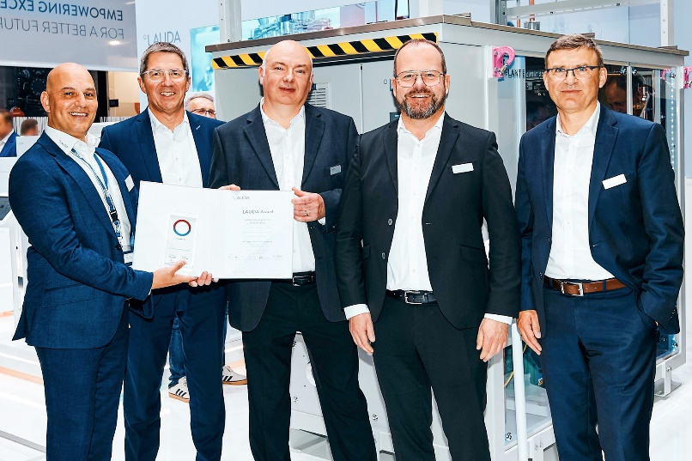
Fig.: Group photo award presentation (from left to right): Paul King (Managing Director LAUDA Technology Ltd.), Dr. Ralf Hermann, CSO of LAUDA, John Telford (Sales Manager Industrial Units LAUDA Technology Ltd.), Dr. Gunther Wobser, President & CEO of LAUDA, and Dr. Thorsten Ebel (Director Area Sales International). © Chris Rausch

We are LAUDA – the world leader in precise temperature control. Our constant temperature equipment and systems are at the heart of important applications, contributing to a better future. As a complete one-stop supplier, we guarantee the optimum temperature in research, production and quality control. We are the reliable partner for electromobility, hydrogen, chemicals, pharmaceuticals/biotech, semiconductors and medical technology. We have been inspiring our customers for almost 70 years with our expert mentoring and innovative solutions – every day anew and all over the world.

In our company, we always go one step further. We support our employees’ development and are constantly developing ourselves: to create a better future together.

Press contact
We are more than happy to make prepared information about our company, the LAUDA Factory Gallery and our projects in the area of innovation promotion, digitalization and idea management available to the press. We look forward to hearing from you – just give us a call!

CHRISTOPH MUHR
Head of Corporate Communications
T + 49 (0) 9343 503-349
christoph.muhr@lauda.de

LAUDA DR. R. WOBSER GMBH & CO. KG, Laudaplatz 1, 97922 Lauda-Königshofen, Deutschland/Germany. Limited partnership: Headquarters Lauda-Königshofen, Registration court Mannheim HRA 560069. General partner: LAUDA DR. R. WOBSER Verwaltungs-GmbH, Headquarters Lauda-Königshofen, Registration court Mannheim HRB 560226. Managing Directors: Dr. Gunther Wobser (President & CEO), Dr. Mario Englert (CFO), Dr. Ralf Hermann (CSO), Dr. Marc Stricker (COO)

