CLOSURE OF NEW.DEGREE GMBH

LAUDA Digital Innovation Hub ceases business operations as of June 30, 2024

Würzburg/Lauda-Königshofen, June 28, 2024 - new.degree GmbH will cease its business operations on June 30, 2024. The wholly owned subsidiary of LAUDA DR. R. WOBSER GMBH & CO. KG, the global market leader for precise temperature control, was founded in 2021 to drive forward the innovation and digitalization of the parent company. There was previously a similar company based in Silicon Valley, USA, but it ceased operations during the pandemic and transferred its tasks to the German company. After careful consideration, the liquidation of new.degree, »The LAUDA Digital Innovation Hub«, will now be completed.

»The closure of new.degree is a decision that was very difficult for me personally. After all, it was my initiative, which I launched full of energy during my stay in Silicon Valley,« explains Dr. Gunther Wobser, President & CEO at LAUDA. »Agile innovation management is still very important to me. However, the last three and a half years have shown that integrating these tasks into the parent company is more efficient.«

Bringing the innovation and digitalization topics back to LAUDA should improve the direct product reference and enable greater economic success in the long term. Only around a year ago, new.degree moved into new offices in the InnoHubs on Skyline Hill in Würzburg, which are now also being vacated. By bundling expertise under the umbrella of the parent company LAUDA DR. R. WOBSER GMBH & CO. KG, digital activities will be more closely aligned with the core business and existing customer relationships.

Dr. Mario Englert, CFO at LAUDA and also Managing Director of new.degree GmbH since the beginning of 2024, explains: »Despite numerous ideas each year, only a few have made the leap to concrete business cases. In the current overall economic situation, it makes more sense for LAUDA to focus on its core competencies and drive digitalization forward by additional hired employees at the company headquarters.«

The closure of new.degree GmbH does not mean the end of comprehensive innovation efforts, but rather represents a strategic step towards a more focused approach at LAUDA. »We would like to thank all former employees of new.degree GmbH for their dedicated work over the past few years,« emphasizes Dr. Gunther Wobser. »The experience and knowledge gained is of great value and will enable us to continue to drive forward the digital transformation at LAUDA in the future and be successful in the long term.«

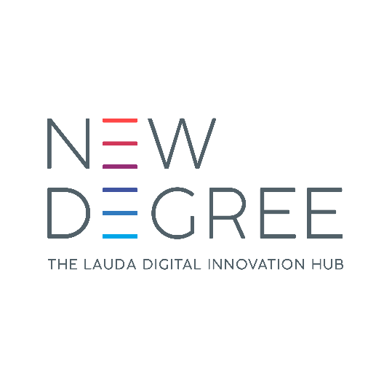

Fig.: Logo of new.degree GmbH - The wholly owned subsidiary of LAUDA DR. R. WOBSER GMBH & CO. KG will cease its business activities on June 30, 2024.

We are LAUDA – the world leader in precise temperature control. Our constant temperature equipment and systems are at the heart of important applications, contributing to a better future. As a complete one-stop supplier, we guarantee the optimum temperature in research, production and quality control. We are the reliable partner for electromobility, hydrogen, chemicals, pharmaceuticals/biotech, semiconductors and medical technology. We have been inspiring our customers for almost 70 years with our expert mentoring and innovative solutions – every day anew and all over the world.

In our company, we always go one step further. We support our employees’ development and are constantly developing ourselves: to create a better future together.

Press contact
We are more than happy to make prepared information about our company, the LAUDA Factory Gallery and our projects in the area of innovation promotion, digitalization and idea management available to the press. We look forward to hearing from you – just give us a call!

CHRISTOPH MUHR
Head of Corporate Communications
T + 49 (0) 9343 503-349
christoph.muhr@lauda.de

LAUDA DR. R. WOBSER GMBH & CO. KG, Laudaplatz 1, 97922 Lauda-Königshofen, Deutschland/Germany. Limited partnership: Headquarters Lauda-Königshofen, Registration court Mannheim HRA 560069. General partner: LAUDA DR. R. WOBSER Verwaltungs-GmbH, Headquarters Lauda-Königshofen, Registration court Mannheim HRB 560226. Managing Directors: Dr. Gunther Wobser (President & CEO), Dr. Mario Englert (CFO), Dr. Ralf Hermann (CSO), Dr. Marc Stricker (COO)

