Global Market Leader Honors Extraordinary Work Anniversary

Rudolf Gräff honored for 50 years of service

Lauda-Königshofen, September 12, 2024 – LAUDA DR. R. WOBSER GMBH & CO. KG recently celebrated an event that is rare in the modern working world: Rudolf Gräff's 50th anniversary with the company. At a ceremony attended by 35 guests, President & CEO Dr. Gunther Wobser acknowledged the anniversary celebrant's decades of commitment and loyalty to the family business.

Rudolf Gräff began his long, impressive career at LAUDA on August 26, 1974 with an apprenticeship as a power electronics technician. After successfully completing his training, he was hired into the electronics department, where he still works today. Over the course of his 50 years with the company, Gräff has distinguished himself through his versatile commitment, e.g. in plant engineering, and his meticulous working methods.

In his laudation, Dr. Gunther Wobser acknowledged the anniversary celebrant's special achievements: »With his reliability and adaptability, Rudolf Gräff stands for important values ​​that have made LAUDA a global market leader. His willingness to face new challenges and technical developments and always deliver outstanding quality is remarkable.«

In recognition of his many years of service, Rudolf Gräff received the LAUDA certificate of honor and, as a special honor, the Dr.-Rudolf-Wobser-Medal in gold – an award from the family company that has only been given to 20 people to date. The honor was complemented by representatives from politics and business: The deputy general manager of the Heilbronn-Franken Chamber of Industry and Commerce, Christof Geiger, presented the Chamber of Industry and Commerce certificate of honor and recognized the services of LAUDA and Gräff to the local economy. Dr. Lukas Braun, Mayor of Lauda-Königshofen, conveyed the city's congratulations and awarded the state's certificate of honor on behalf of the Prime Minister of Baden-Württemberg.

In his acceptance speech, Rudolf Gräff emphasized his deep connection with the company and expressed his pride in being part of the LAUDA success story. Gräff's career at LAUDA is also a reflection of the company's history: He personally experienced all three generations of managing directors of the Wobser family and began his career in the era of the company's founder, Dr. Rudolf Wobser.

Rudolf Gräff's extraordinary anniversary underlines the role of LAUDA as a responsible family business. It impressively shows how valuable many years of experience and loyal employees are for sustainable success in a constantly changing working world.

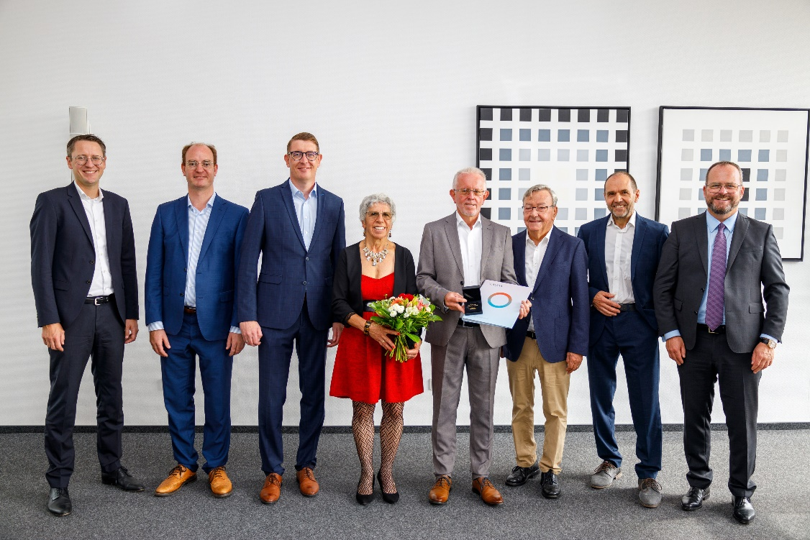

Fig.: Special employee recognition at LAUDA: Rudolf Gräff (center) was awarded the Dr.-Rudolf-Wobser-Medal for half a century of service to the company. The President & CEO of the global market leader, Dr. Gunther Wobser (right), together with CFO Dr. Mario Englert (left), Mayor Dr. Lukas Braun and IHK representative Christof Geiger as well as Dr. Gerhard Wobser and Works Council Chairman Elmar Mohr, paid tribute to the exceptional career of the jubilarian. © LAUDA

We are LAUDA – the world leader in precise temperature control. Our constant temperature equipment and systems are at the heart of important applications, contributing to a better future. As a complete one-stop supplier, we guarantee the optimum temperature in research, production and quality control. We are the reliable partner for electromobility, hydrogen, chemicals, pharmaceuticals/biotech, semiconductors and medical technology. We have been inspiring our customers for almost 70 years with our expert mentoring and innovative solutions – every day anew and all over the world.

In our company, we always go one step further. We support our employees’ development and are constantly developing ourselves: to create a better future together.

Press contact
We are more than happy to make prepared information about our company, the LAUDA Factory Gallery and our projects in the area of innovation promotion, digitalization and idea management available to the press. We look forward to hearing from you – just give us a call!

CHRISTOPH MUHR
Director Corporate Communications
T + 49 (0) 9343 503-349
christoph.muhr@lauda.de

LAUDA DR. R. WOBSER GMBH & CO. KG, Laudaplatz 1, 97922 Lauda-Königshofen, Deutschland/Germany. Limited partnership: Headquarters Lauda-Königshofen, Registration court Mannheim HRA 560069. General partner: LAUDA DR. R. WOBSER Verwaltungs-GmbH, Headquarters Lauda-Königshofen, Registration court Mannheim HRB 560226. Managing Directors: Dr. Gunther Wobser (President & CEO), Dr. Mario Englert (CFO), Dr. Marc Stricker (COO)

